CHAPTER ONE

DIRECT SEQUENCE SPREAD SPECTRUM

  - Overview

This chapter presents information on direct sequence spread spectrum (DS-SS) and how it can be used to combat the effects of fading and interference. It also overviews code-division multiple-access (CDMA), a technology that uses DS-SS to enable sharing of frequency spectrum by many users.

  - History of Spread Spectrum

Spread spectrum (SS) communications technology was first described on paper by an actress and a musician! In 1941, Hollywood actress Hedy Lamarr and pianist George Antheil described a secure radio link to control torpedoes. It was not taken seriously at that time by the U.S. Army and was forgotten until the 1980s. The time after, it has become increasingly popular for applications that involve radio links in hostile environments. Typical applications for the resulting short-range data transceivers include satellite-positioning systems (GPS) and Bluetooth. SS techniques also aid in the endless race between communication needs and radio-frequency availability (the radio spectrum is limited, and is therefore an expensive resource) [3].

  - DS-SS and CDMA

In telecommunications, direct-sequence spread spectrum (DS-SS) is a modulation technique. As with other spread spectrum technologies, the transmitted signal takes up more bandwidth than the information signal that is being modulated. The name "spread spectrum" comes from the fact that the carrier signals occur over the full bandwidth (spectrum) of a device's transmitting frequency.
Channel
encoder
Modulator
Channel
Demodulator
Channel
decoder
Pseudorandom pattern generator
Pseudorandom pattern generator
Information
sequence
Output
data

Figure 1.1 Model of spread spectrum digital communication system
DS-SS is a phase-modulates a sine wave pseudo randomly with a continuous string of pseudo noise (PN) code symbols called chips as shown in Figure 1.1. Each of which has a much shorter duration than an information bit. That is, each information bit is modulated by a sequence of much faster chips. Therefore, the chip rate is much higher than the information signal bit rate. It uses a signal structure in which the sequence of chips produced by the transmitter is a known priori by the receiver. The receiver can then use the same PN sequence to counteract the effect of the PN sequence on the received signal in order to reconstruct the information signal. Code division multiple access (CDMA) is one of the DS-SS technologies. Thus, it is a form of multiplexing and a method of multiple access to a physical medium such as a radio channel, where different users use the medium at the same time due to their use of different code sequences. By contrast, time division multiple access divides access by time, while frequency-division multiple access divides it by frequency. CDMA is a form of spread spectrum signaling, since the modulated coded signal has a much higher bandwidth than the data being communicated. An analogy to the problem of multiple access is a room (channel) in which people wish to communicate with each other. To avoid confusion, people could take turns speaking (time division), speak at different pitches (frequency division), or speak in different directions (spatial division). In CDMA, they would speak different languages. People speaking the same language can understand each other, but not other people. Similarly, in radio CDMA, each group of users is given a shared code. Many codes occupy the same channel, but only users associated with a particular code can understand each other [4].

    - How DS-SS Works?

Direct-sequence spread-spectrum transmissions multiply the data being transmitted by a noise signal. This noise signal is a pseudo random sequence of 1 and −1 values, at a frequency much higher than that of the original signal, thereby spreading the energy of the original signal into a much wider band. The resulting signal resembles white noise. However, this noise-like signal can be used to exactly reconstruct the original data at the receiving end, by multiplying it by the same pseudo random sequence (because 1 × 1 = 1, and −1 × −1 = 1). This process, known as despreading, mathematically constitutes a correlation of the transmitted PN sequence with the receiver's assumed sequence. For despreading to work correctly, the transmit and receive sequences must be synchronized. This requires the receiver to synchronize its sequence with the transmitter's sequence via some sort of timing search process. However, this apparent drawback can be a significant benefit: if the sequences of multiple transmitters are synchronized with each other, the relative synchronizations the receiver must make between them can be used to determine relative timing, which in turn, can be used to calculate the receiver's position if the transmitters' position is known. This is the basis for many satellite navigation systems. The resulting effect of enhancing signal-to-noise ratio on the channel is called processing gain. This effect can be made larger by employing a longer PN sequence and more chips per bit, but physical devices used to generate the PN sequence impose practical limits on attainable processing gain. If an undesired transmitter transmits on the same channel but with a different PN sequence (or no sequence at all), the de-spreading process results in no processing gain for that signal. This effect is the basis for the CDMA property of DS-SS, which allows multiple transmitters to share the same channel within the limits of the cross-correlation properties of their PN sequences. As this description suggests, a plot of the transmitted waveform has a roughly bell-shaped envelope centered on the carrier frequency, just like a normal AM transmission, except that the added noise causes the distribution to be much wider than that of an AM transmission. In contrast, frequency-hopping spread spectrum pseudo randomly re-tunes the carrier, instead of adding pseudo random noise to the data, which results in a uniform frequency distribution whose width is determined by the output range of the pseudo random number generator [7].

    - CDMA System

In a CDMA system, each user's narrowband message is multiplied by a long pseudo noise (PN) sequence, called the spreading signal. The PN sequence is comprised of random symbols called chips and has a chip rate which is in orders of magnitude greater than the data rate of the message. This effectively spreads the narrowband signal energy over a much larger bandwidth. Figure 1.2 illustrates the spreading effect of the PN sequence. In the figure, b(t) is the baseband message signal with bit duration T, a(t) is the spreading sequence with chip duration T_{c}, and B(f) and C(f) are the spectrum of the message before and after spreading, respectively. This spreading of the user's signal serves two purposes. First, it provides a simple form of security because it hides the user's signal within the noise floor. In order to receive the signal, a receiver must correlate the received signal with a locally generated replica of the PN carrier. As a result, only those receivers who have knowledge of the user's PN sequence can acquire the user's message. Second, it provides resistance to narrowband interference within the bandwidth of the signal [6].

Figure 1.2 Spread Spectrum Encoding [6].

The decorrelation process used to despread the user's signal at the receiver spreads the energy of the narrowband interference over a much larger bandwidth causing it to be seen as noise. In an ideal CDMA system, each user's signal would be spread by a unique PN code which is mutually orthogonal to the PN code of all other user's. The orthogonality of the PN sequences provides code diversity between each user's signal, allowing all users to share the same spectrum, and thus explaining the name code division multiple access. When a particular user's signal is despread at the receiver through correlation with an identical PN sequence, all other user's PN sequences are highly uncorrelated and seen as noise. Thus, CDMA offers resistance to multiple access interference. In practice, the base station in the forward channel of a CDMA system is able to simultaneously transmit user signals spread by orthogonal PN sequences. However, user signals in the reverse channel are asynchronous and non-orthogonal. A CDMA system is considered asynchronous if the PN sequences from different user's are not chip and bit aligned [6]. In the reverse channel, each user's PN sequence is generated based on the mobile unit's Electronic Serial Number (ESN). While each ESN is unique, they generally do not produce a PN sequence that is orthogonal to all other PN sequences. Consequently, the reverse channel is susceptible to multiple access interference. Since each user is allowed to occupy the same duplex channel, CDMA systems do not require frequency reuse or channel allocation throughout the system, unlike TDMA and FDMA systems. CDMA systems also offer resistance to multipath interference. When a user's signal is dispread during the correlation process at the receiver, the locally generated replica of the user's PN code is aligned with the line-of-sight (LOS) signal, assuming that the LOS signal has the greatest signal power. When the LOS and multipath components signal are separated by more than one chip, the multipath signal is highly uncorrelated and seen as noise. As a result, the interference due to multipath lying outside of one chip is minimized. Another advantage that CDMA systems offer is capacity improvement. The IS-54 and AMPS cellular standards have a hard limit on the number of users that it can support because of the limited number of available channels. Since all users within a CDMA system occupy the same channel, there is not a limited number of user channels that can be occupied. However, because the interference levels increase as the number of users increase, there is a soft capacity limit in which CDMA systems can maintain acceptable signal quality. Capacity improvements are also realized by the systems ability to exploit the voice activity of a call. Typical voice activity during a normal conversation is approximately 40% or less. During the silent periods, in which there is no voice activity, the data rate of the variable rate speech encoder in the mobile unit is reduced, code symbols are repeated to maintain a constant code rate and the unit is instructed to reduce its transmit duty cycle. This reduces the interference contributed by the mobile unit. As a result, more users can be accommodated within the same spectrum.

      - Illustrative Example of CDMA

Below an example of a CDMA system is given. User one's chip code is generated as [1 -1 1 -1], user two's chip code is generated as [1 1 -1 -1], and user three's chip code is generated as [-1 1 1 -1]. If user one wants to send the data 1 (bit 1), -1 (bit 0), 1 (bit 1), -1 (bit 0), for example, each bit is repeated four times and multiplied with chip 1 (1 -1 1 -1). Same operation is repeated for user 2 and user 3. Since they all transmit over the same channel, the signals are then added together.

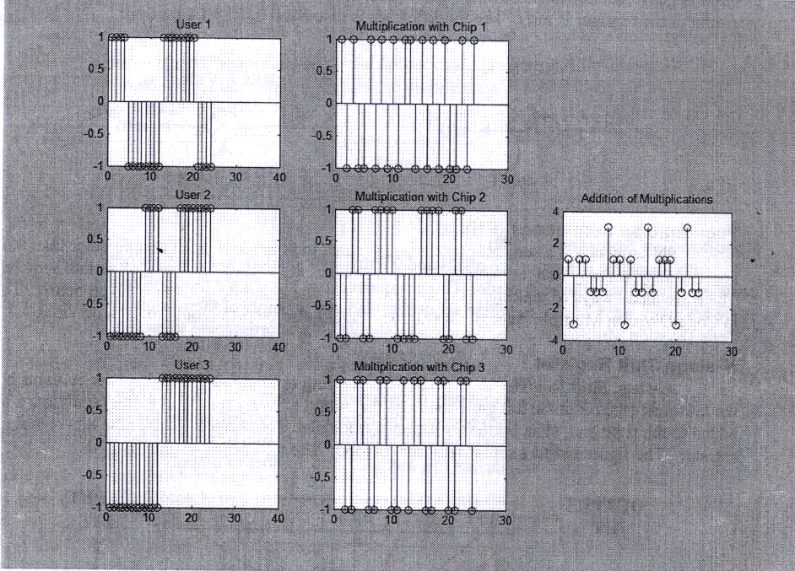
Figure 1.3 An illustrative example of CDMA [4].
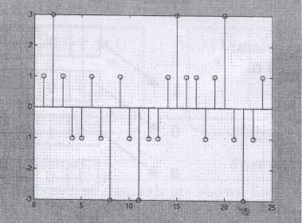

Figure 1.4 Multiplication of channel signal with chip 1 [4].

At the receiver, for user 1, the channel signal is multiplied with chip 1, and then for each bit period (4 samples), samples are added and divided by 4 (number of samples). For example, in Figure 1.4 the signal is multiplied with chip 1. When the first four samples are added (1 3 1 -1), and divided by 4 a result of 1 is obtained. This is the first bit. Then the next four samples (-1 1 -1 -3) are added together and divided by 4 to give a -1. This is the second bit. This is continued until all the data is received.

  - Summary

In this chapter, the DS-SS technology is explained. In addition, CDMA is presented along with its historical side, advantages and disadvantages.
Next chapter will present a background on information theory and error-correcting codes, including cyclic codes and convolutional codes.

